Omiga.Net

SFTP Setup

Lee Harrison

Business Technology Services
Version 1.2

Date 9th January 2008

For Circulation to:

Darren Santaeulalia

Contents
1. Introduction 3
1.1 Scope 3
2. FileZilla 4
2.1 Adding a New Site 4
2.2 Connecting 5

Introduction
Omiga.Net requires access to an SFTP server so files can be shared between the development company (ArtinSoft) and Vertex staff.

Scope
The following information will detail how to setup and configure the client to access the SFTP server.

FileZilla
The application used for the SFTP facility is FileZilla. This is a free FTP solution available from http://filezilla-project.org/. To connect to the Vertex SFTP server you will need the FileZilla client. The information below details how to configure FileZilla version 3.0.5 so it can connect to the SFTP resource.

Adding a New Site
To connect using FileZilla a site needs to be created and the connection details specified.

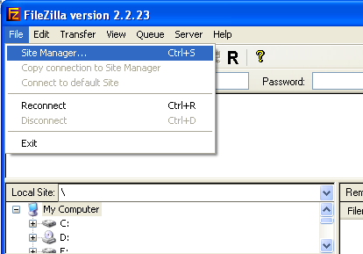
Select File > Site Manager to add a new Site
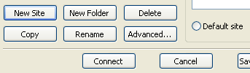
Click New Site
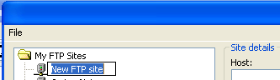 | Enter a name for the Site
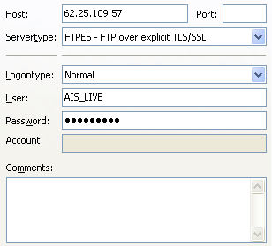 | Enter Host IP Address and select FTPES – FTP over explicit TLS/SSL
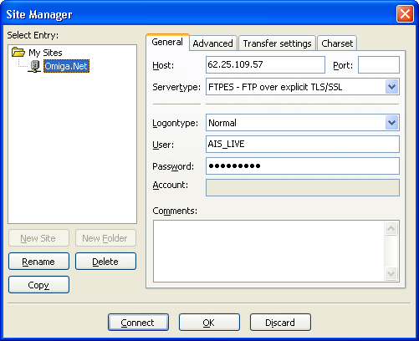
Full view of New Site Screen

Connecting

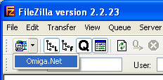 | Either use the Connect button on the Site Manager dialog, or on the main toolbar, click the drop down and select the Site to connect.
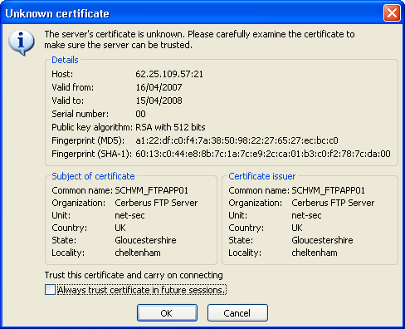 | If the “Unknown certificate” message appears, tick “Always trust certificate in future sessions” and click OK.
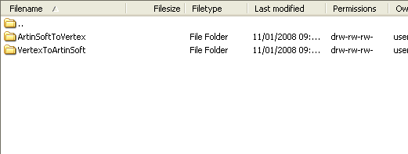 | In the Remote Site, you should see the directories:  ArtinSoftToVertex  VertexToArtinSoft
Note that the connection will automatically time out and disconnect if it is not used.

File Management
The ArtinSoftToVertex directory must be used for transferring files from ArtinSoft to Vertex.
The VertexToArtinSoft directory must be used for transferring files from Vertex to ArtinSoft.
There is limited storage space available on the FTP server, so it must only be used for temporary storage of files during file transfers, and not for long-term file storage. Once files have been successfully received, they should be removed from the FTP server by the recipient.
Therefore the responsibilities are as follows:
ArtinSoft
- Putting files into the ArtinSoftToVertex directory.
- Getting files from the VertexToArtinSoft directory.
- Removing files from the VertexToArtinSoft directory.
Vertex
- Putting files into the VertexToArtinSoft directory.
- Getting files from the ArtinSoftToVertex directory.
- Removing files from the ArtinSoftToVertex directory.
Large files should be compressed in pkzip/winzip/InstallShield format before placing on the FTP server.
Sub-directories may be created as required below the ArtinSoftToVertex and the VertexToArtinSoft directories.

